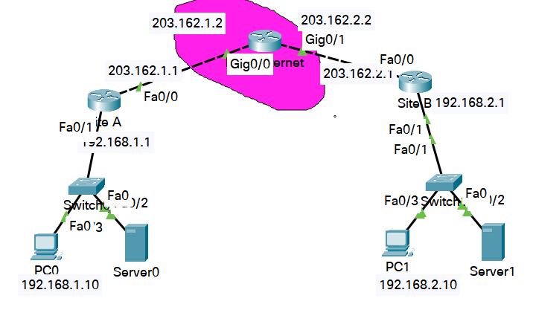
ISAKMP: Internet Security Association and Key Management Protocol
Router 2811
1. Cấu hình NAT out tại 2 site
Tại site-A
RouteAr(config-if)#interface f0/0
RouterA(config-if)#ip nat outside
RouterA(config-if)#interface f0/1
RouterA(config-if)#ip nat inside

RouterA(config)#ip access-list extended out
RouterA(config-ext-nacl)#deny ip 192.168.1.0 0.0.0.255 192.168.2.0 0.0.0.255
RouterA(config-ext-nacl)#permit ip 192.168.1.0 0.0.0.255 any

RouterA(config-ext-nacl)#exit
RouterA(config)#ip nat inside source list out interface F0/0 overload

routerA(config)#ip route 0.0.0.0 0.0.0.0 203.162.1.2

Tại site-B
RouterB(config-if)#interface G0/0
RouterB(config-if)#ip nat outside
RouterB(config-if)#interface F0/1
RouterB(config-if)#ip nat inside

RouterB(config)#ip access-list extended out
RouterB(config-ext-nacl)#deny ip 192.168.2.0 0.0.0.255 192.168.1.0 0.0.0.255
RouterB(config-ext-nacl)#permit ip 192.168.2.0 0.0.0.255 any

RouterB(config-ext-nacl)#exit
RouterB(config)#ip nat inside source list out interface F0/0 overload

routerB(config)#ip route 0.0.0.0 0.0.0.0 203.162.2.2
Các pc bên trong có thể ra internet

2. Cấu hình vpn site to site
Tại site-A
routerA(config)#crypto isakmp policy 9 ; Set policy for an ISAKMP protection suite
; Priority of protection suite =9
routerA(config-isakmp)#hash md5
routerA(config-isakmp)#authentication pre-share
routerA(config-isakmp)#exit

routerA(config)#crypto isakmp key siteab address 203.162.2.1
; Set pre-shared key for remote peer
; 2 site phải cùng key
routerA(config)#access-list 100 permit ip 192.168.1.0 0.0.0.255 192.168.2.0 0.0.0.255

routerA(config)#crypto ipsec transform-set MYSET esp-3des esp-md5-hmac
; Define transform and settings
routerA(config)#crypto map MAP_RA 10 ipsec-isakmp ; Enter a crypto map
routerA(config-crypto-map)#set peer 203.162.2.1
routerA(config-crypto-map)#set transform-set MYSET
routerA(config-crypto-map)#match address 100 ;Match address of packets to encrypt
routerA(config-crypto-map)#exit

routerA(config)#interface f0/0
routerA(config-if)#crypto map MAP_RA
Tại site-B
routerB(config)#crypto isakmp policy 9 ; Set policy for an ISAKMP protection suite
; Priority of protection suite =9
routerB(config-isakmp)#hash md5
routerB(config-isakmp)#authentication pre-share
routerB(config-isakmp)#exit

routerB(config)#crypto isakmp key siteab address 203.162.1.1 ; Set pre-shared key for remote peer
routerB(config)#access-list 100 permit ip 192.168.2.0 0.0.0.255 192.168.1.0 0.0.0.255

routerB(config)#crypto ipsec transform-set MYSET esp-3des esp-md5-hmac
; Define transform and settings
routerB(config)#crypto map MAP_RB 10 ipsec-isakmp ; Enter a crypto map
routerB(config-crypto-map)#set peer 203.162.1.1
routerB(config-crypto-map)#set transform-set MYSET
routerB(config-crypto-map)#match address 100 ;Match address of packets to encrypt
routerB(config-crypto-map)#exit

routerB(config)#interface f0/0
routerB(config-if)#crypto map MAP_RB
routerB(config-if)#end
Kết quả các pc giữa 2 site pinh thành công

Xem thông tin kết nối VPN:
Router# show crypto ipsec sa ; IPSEC SA table
Router# show crypto ipsec transform-set ; Crypto transform sets
Router#show crypto map ; Crypto maps
Router#show crypto isakmp policy ; Show ISAKMP protection suite policy
Router#show crypto isakmp sa ; Show ISAKMP Security Associations
Sa: IPSEC SA table
Router#show crypto ipsec sa

interface: FastEthernet0/0
Crypto map tag: MAP_RA, local addr 203.162.1.1

protected vrf: (none)
local ident (addr/mask/prot/port): (192.168.1.0/255.255.255.0/0/0)
remote ident (addr/mask/prot/port): (192.168.2.0/255.255.255.0/0/0)
current_peer 203.162.2.1 port 500
PERMIT, flags={origin_is_acl,}
#pkts encaps: 3, #pkts encrypt: 3, #pkts digest: 0
#pkts decaps: 3, #pkts decrypt: 3, #pkts verify: 0
#pkts compressed: 0, #pkts decompressed: 0
#pkts not compressed: 0, #pkts compr. failed: 0
#pkts not decompressed: 0, #pkts decompress failed: 0
#send errors 1, #recv errors 0

local crypto endpt.: 203.162.1.1, remote crypto endpt.:203.162.2.1
path mtu 1500, ip mtu 1500, ip mtu idb FastEthernet0/0
current outbound spi: 0xE16D9F7A(3782057850)

inbound esp sas:
spi: 0x6521A142(1696702786)
transform: esp-3des esp-md5-hmac ,
in use settings ={Tunnel, }
conn id: 2000, flow_id: FPGA:1, crypto map: MAP_RA
sa timing: remaining key lifetime (k/sec): (4525504/2956)
IV size: 16 bytes
replay detection support: N
Status: ACTIVE

inbound ah sas:

inbound pcp sas:

outbound esp sas:
spi: 0xE16D9F7A(3782057850)
transform: esp-3des esp-md5-hmac ,
in use settings ={Tunnel, }
conn id: 2001, flow_id: FPGA:1, crypto map: MAP_RA
sa timing: remaining key lifetime (k/sec): (4525504/2956)
IV size: 16 bytes
replay detection support: N
Status: ACTIVE

outbound ah sas:

outbound pcp sas:

transform-set: Crypto transform sets
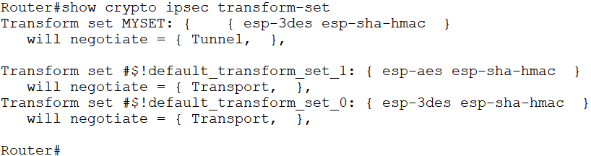
Map: Crypto maps
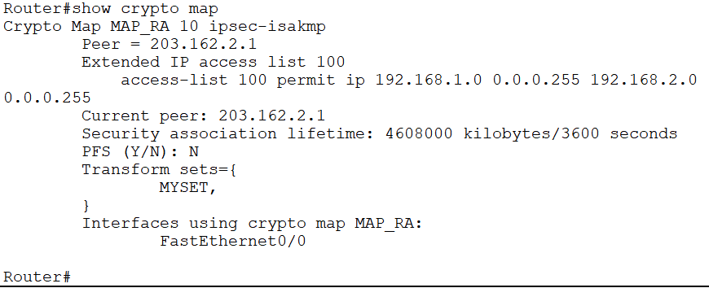
Policy: Show ISAKMP protection suite policy
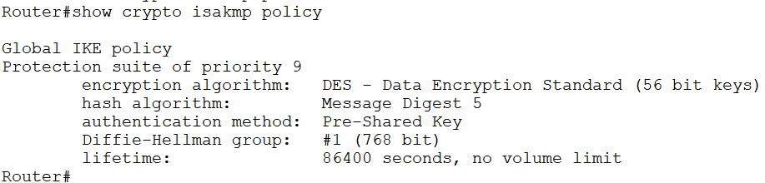

Sa: Show ISAKMP Security Associations
